Name - Shubham Rajendra Gorade
PRN - 260840320163

create database restaurant;
use restaurant;

Q1
create table res_department (dept_id int, dept_name varchar(30));
create table res_employee (emp_id int, emp_name varchar(30), mob_no int, emp_dep_id int);
create table res_menu (menu_id int, menu_name varchar(20), taste varchar(30));
create table res_customer (cus_id int, cus_name varchar(30), food_name varchar(10), food_id int);
create table res_rating (rating int, rat_name varchar(30), rat_id_cus int);

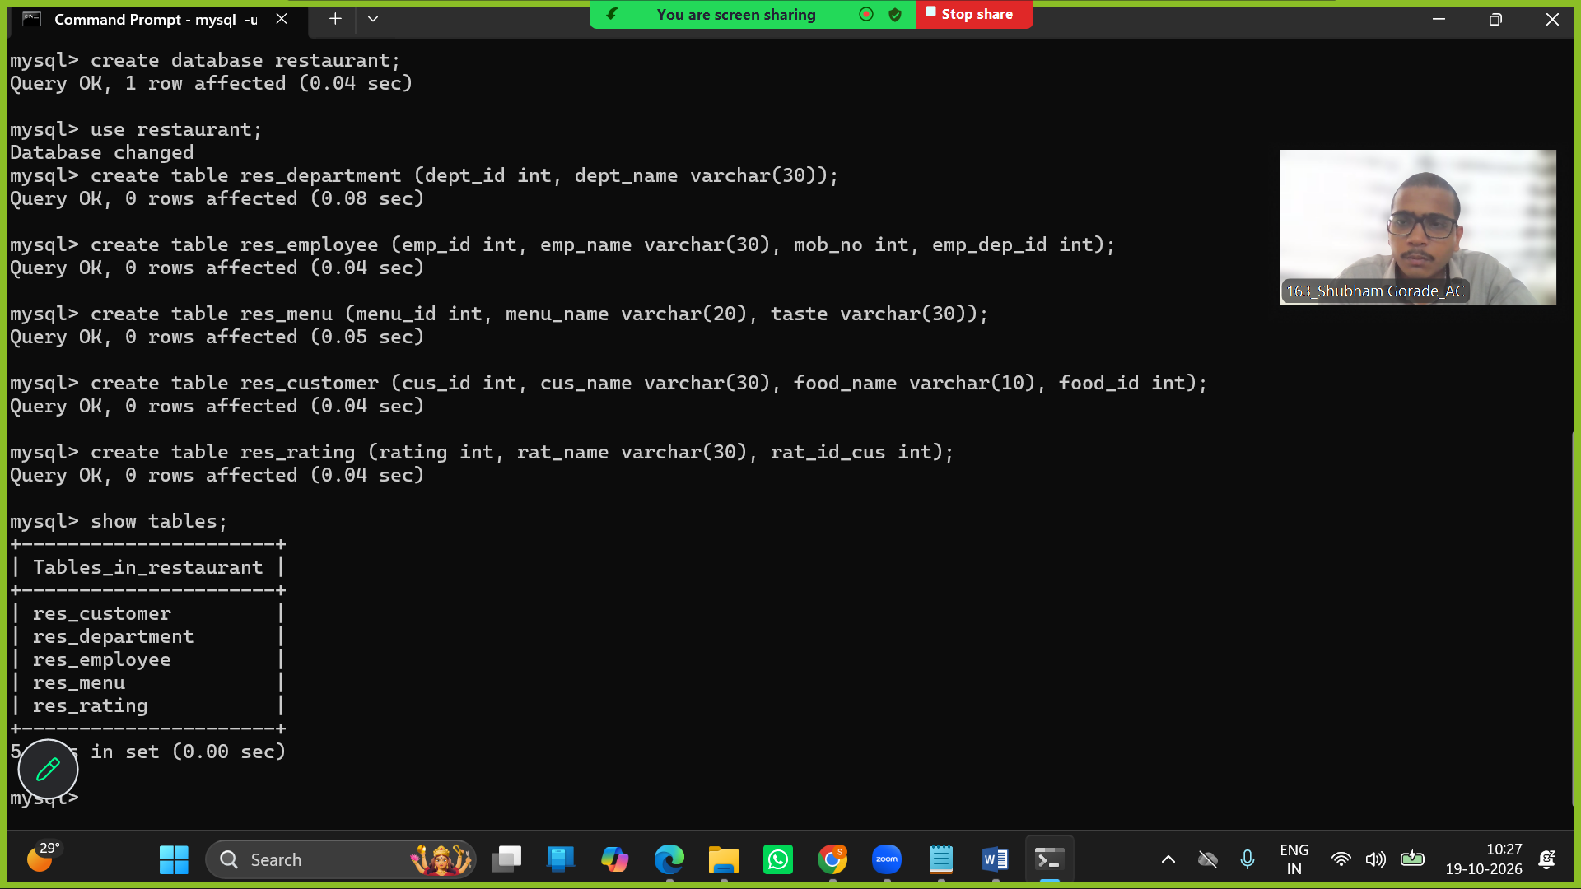

Q2
alter table res_department
add primary key(dept_id);

alter table res_employee
add primary key(emp_id);

alter table res_menu
add primary key(menu_id);

alter table res_customer
add primary key(cus_id);

alter table res_rating
add primary key(rat_name);

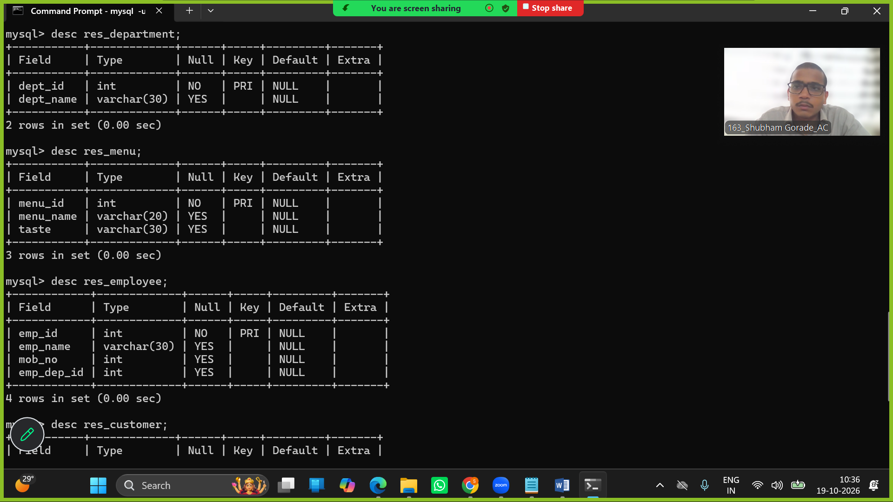

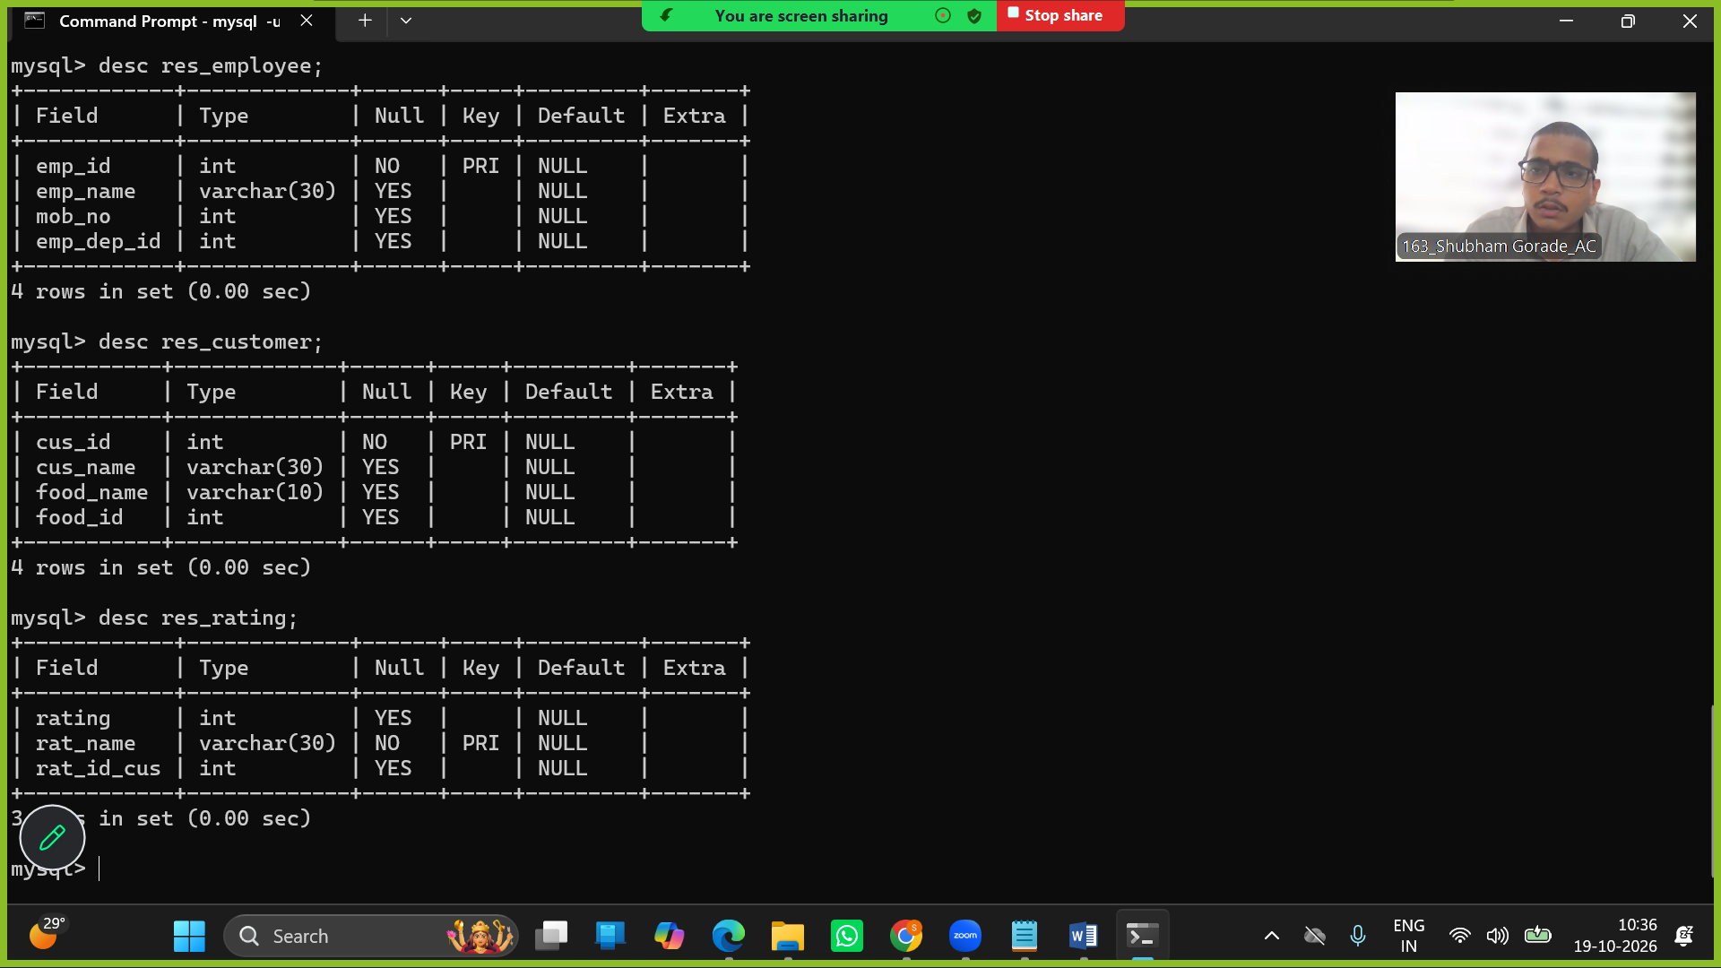

Q3
insert into res_department values
(1, 'owner'),
(2, 'manager'),
(3, 'server'),
(4, 'foodmaker'),
(5, 'cashier');

insert into res_employee values
(1, 'Shubham', 1234, 1),
(2, 'Sujal', 12345, 2),
(3, 'Sai', 123456, 3),
(4, 'Rahul', 12345543, 4),
(5, 'Shau', 123, 5),
(6, 'Rahul', 12344646, 4);

insert into res_menu values
(1, 'paneer', 'spicy'),
(2, 'chineese', 'hot'),
(3, 'chiken', 'spicy'),
(4, 'fish', 'spicy and tasty'),
(5, 'milk', 'hot');

insert into res_customer values
(1, 'Shu', 'paneer', 1),
(2, 'Suj', 'paneer', 1),
(3, 'Pushkar', 'milk', 5),
(4, 'Raj', 'fish', 4),
(5, 'Sid', 'chiken', 3);

insert into res_rating values
(5, 'Shu', 1),
(4, 'Suj', 2),
(4, 'Pushkar', 3),
(5, 'Raj', 4),
(5, 'Sid', 5);
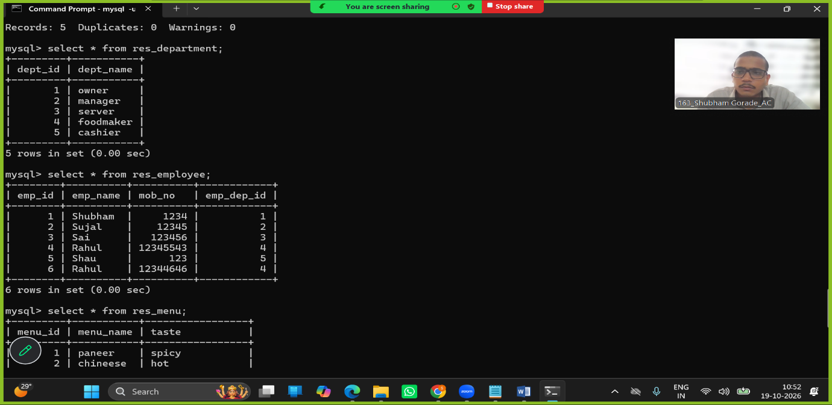
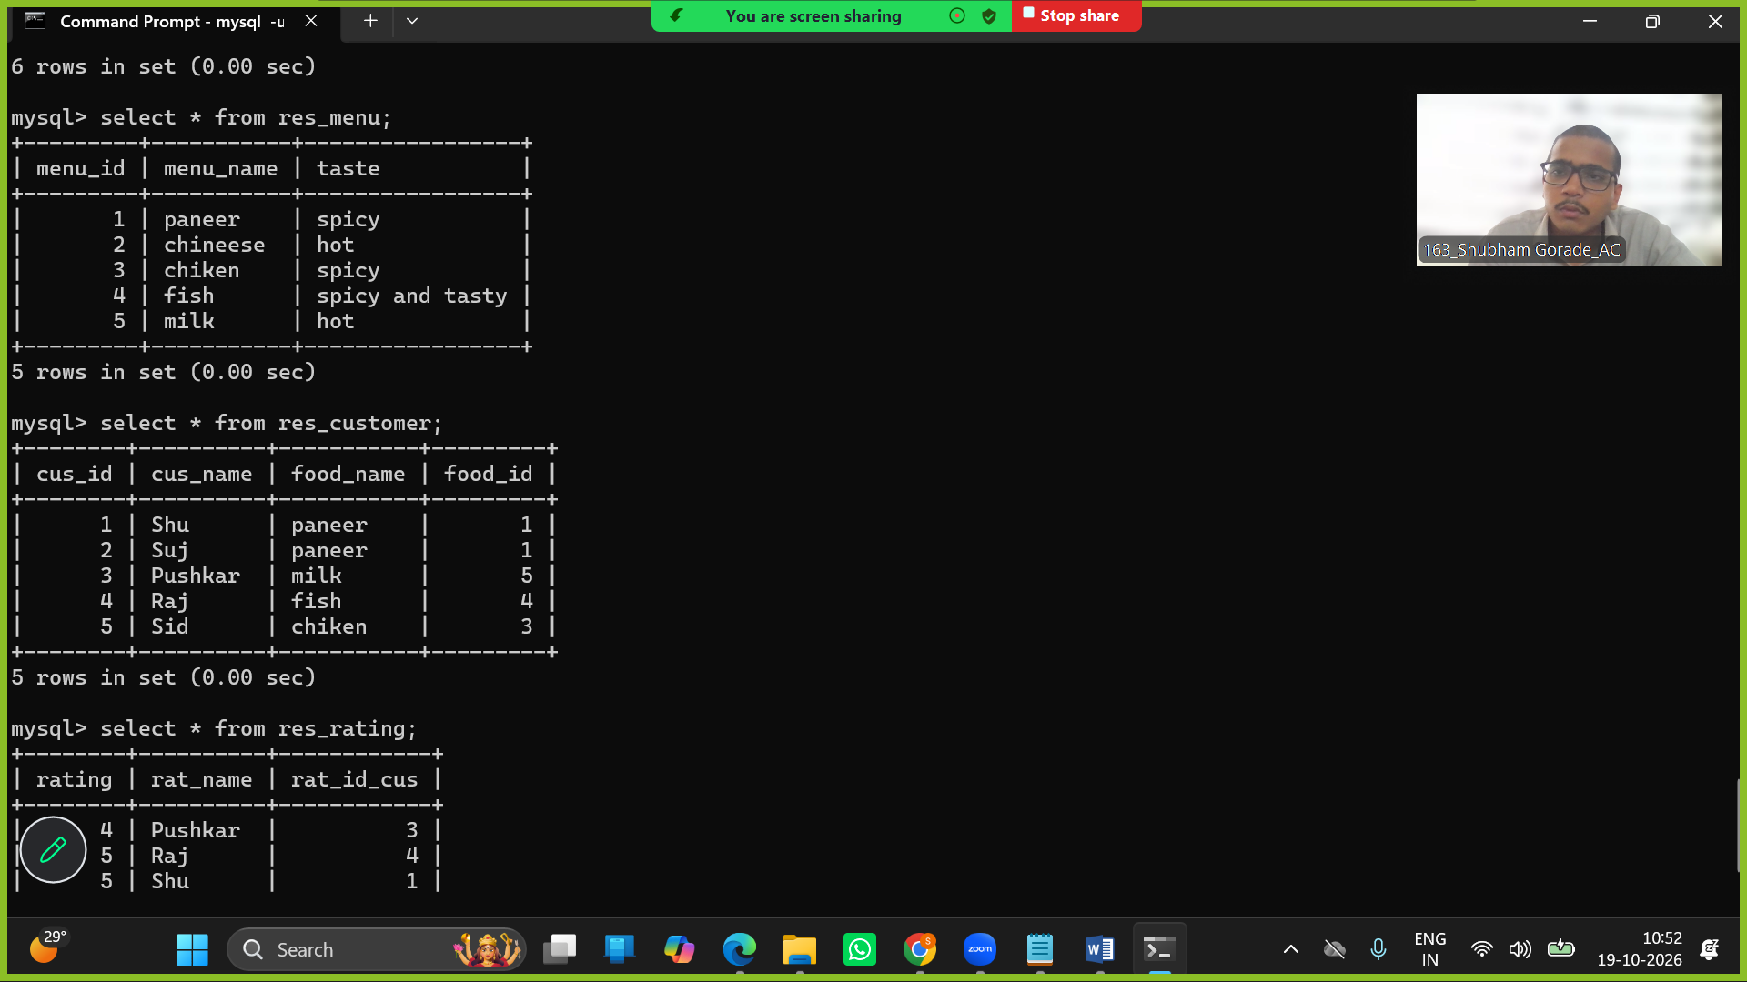

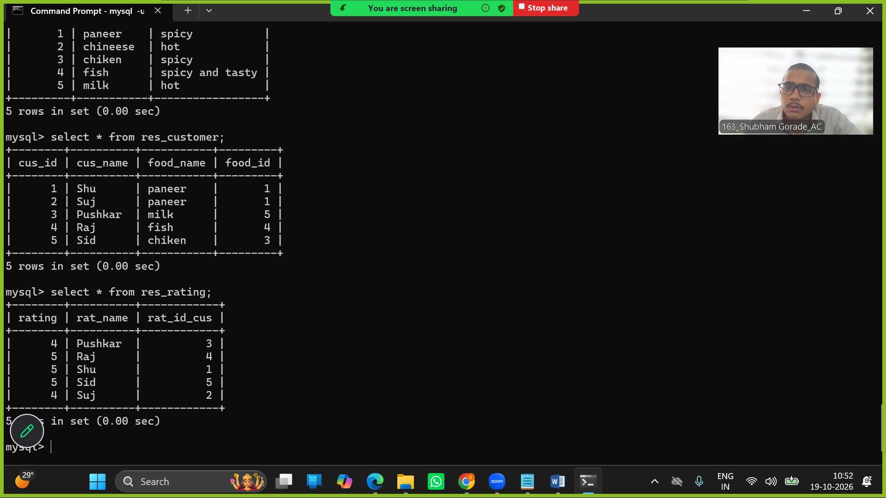

Q4
alter table res_employee
add foreign key(emp_dep_id) references res_department(dept_id);

alter table res_customer
add foreign key(food_id) references res_menu(menu_id);

alter table res_rating
add foreign key(rat_id_cus) references res_customer(cus_id);

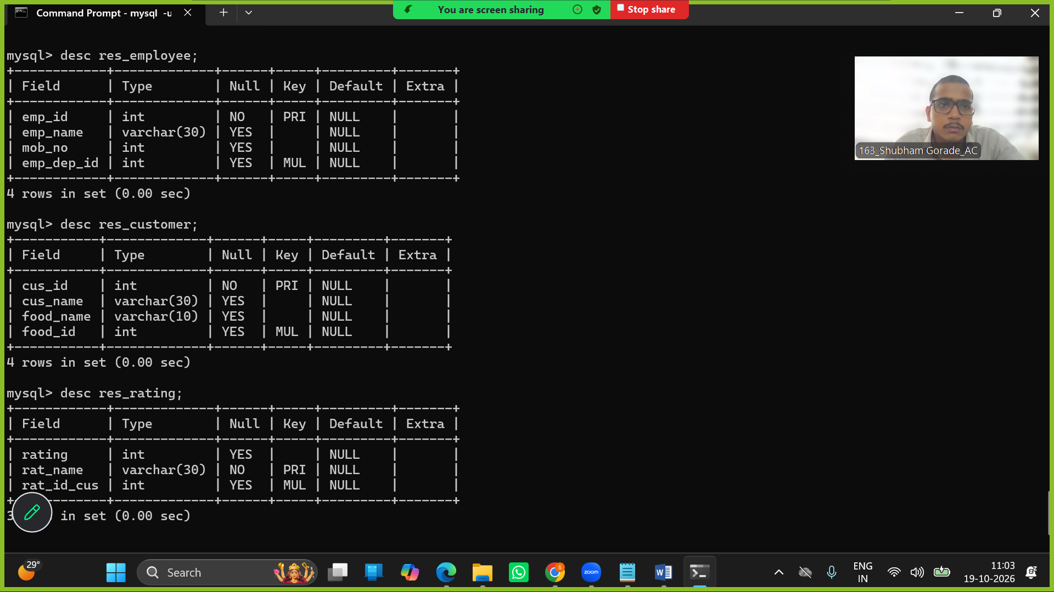

Q5
select emp_id, emp_name, emp_dep_id from res_employee
where emp_id>=2 or emp_dep_id >=3;

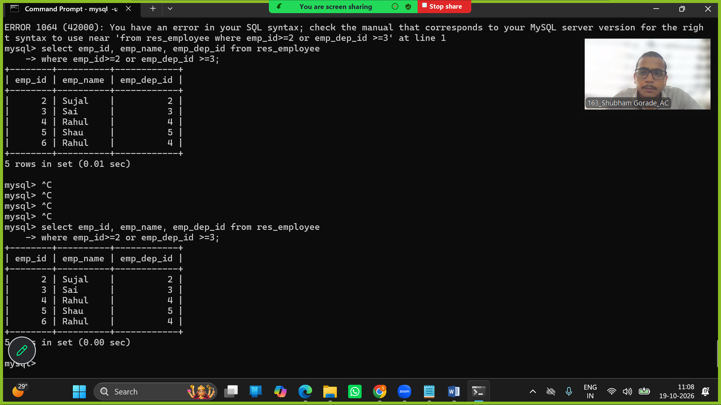

Q6

Q7
select count(emp_id) as total_no_of_foodmaker from res_employee
group by emp_dep_id;

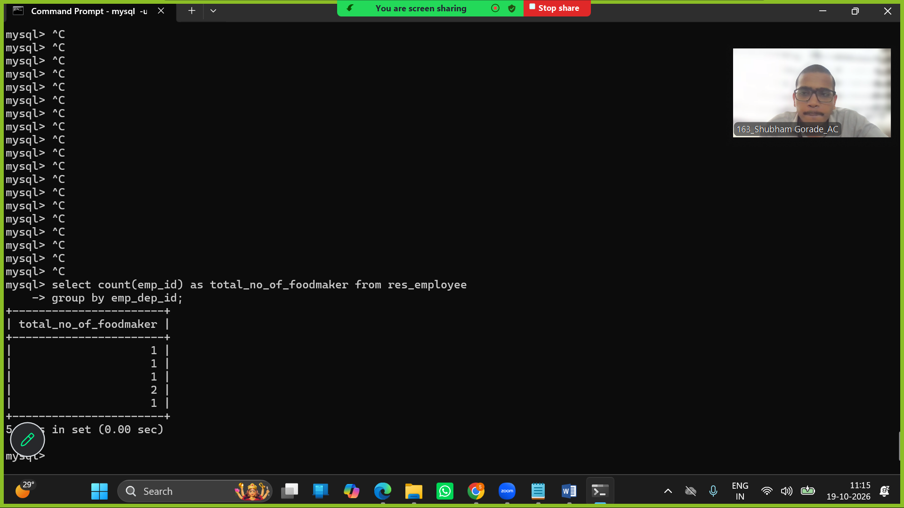

Q8
alter table res_menu
add column cost int;

update res_menu set cost = 150 where menu_id=1;
update res_menu set cost = 250 where menu_id=2;
update res_menu set cost = 300 where menu_id=3;
update res_menu set cost = 150 where menu_id=4;
update res_menu set cost = 10 where menu_id=5;

select max(cost) as costliest_dish from res_menu;

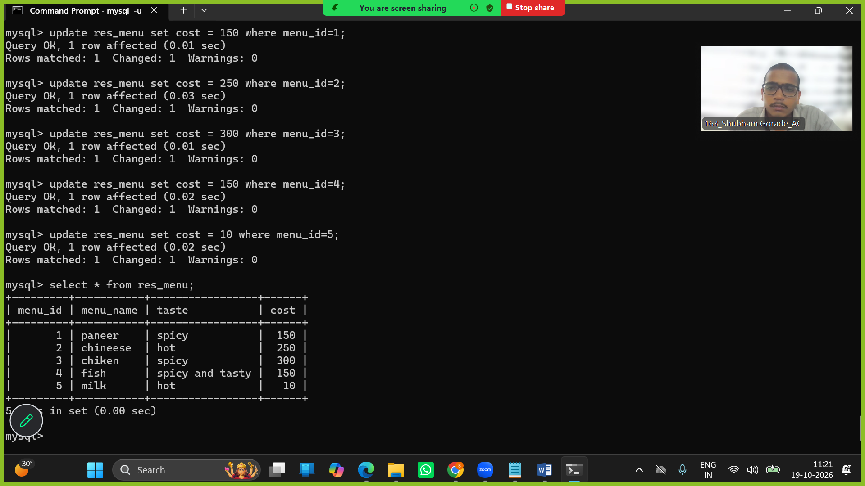

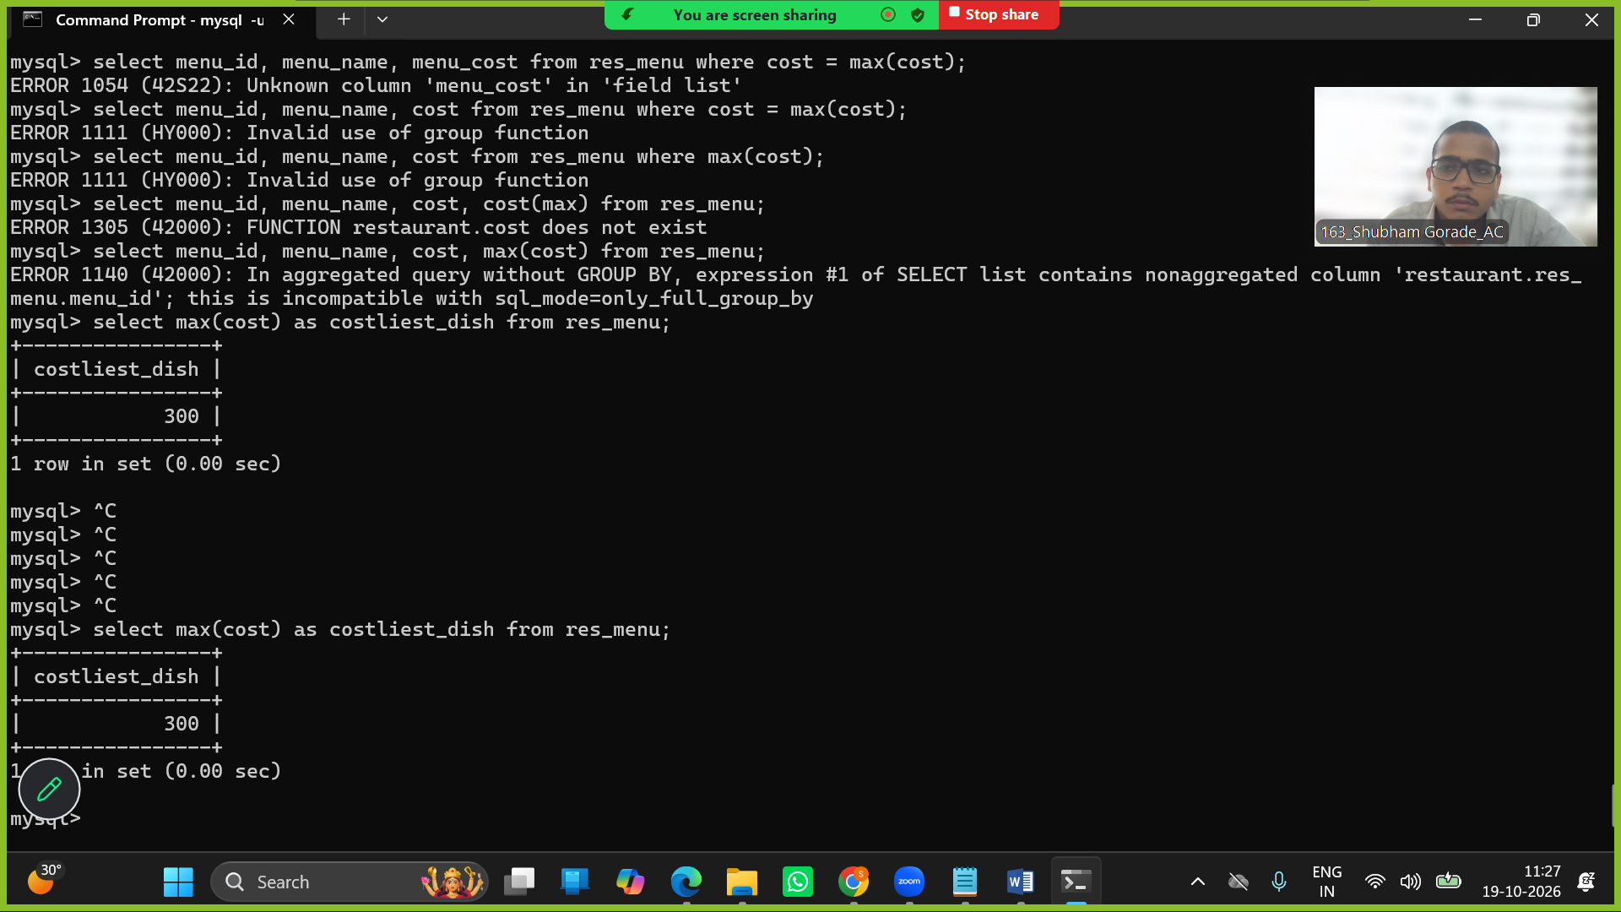

Q9
create view res_emp_view as
select * from res_employee;

select * from res_emp_view;

update res_emp_view set emp_name = 'Rahul Talole' where emp_id=6;
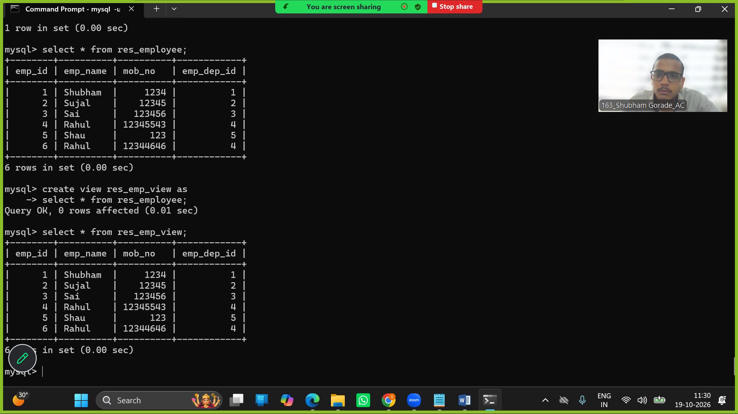
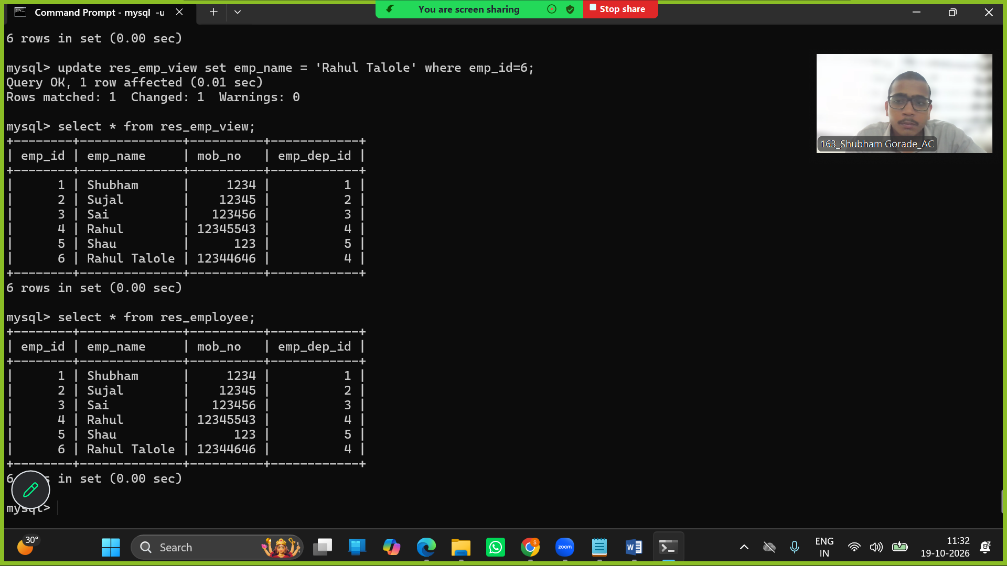

Q10
select d.dept_name, e.emp_id, e.emp_name from
res_department as d
left join res_employee as e
on d.dept_id=e.emp_dep_id;

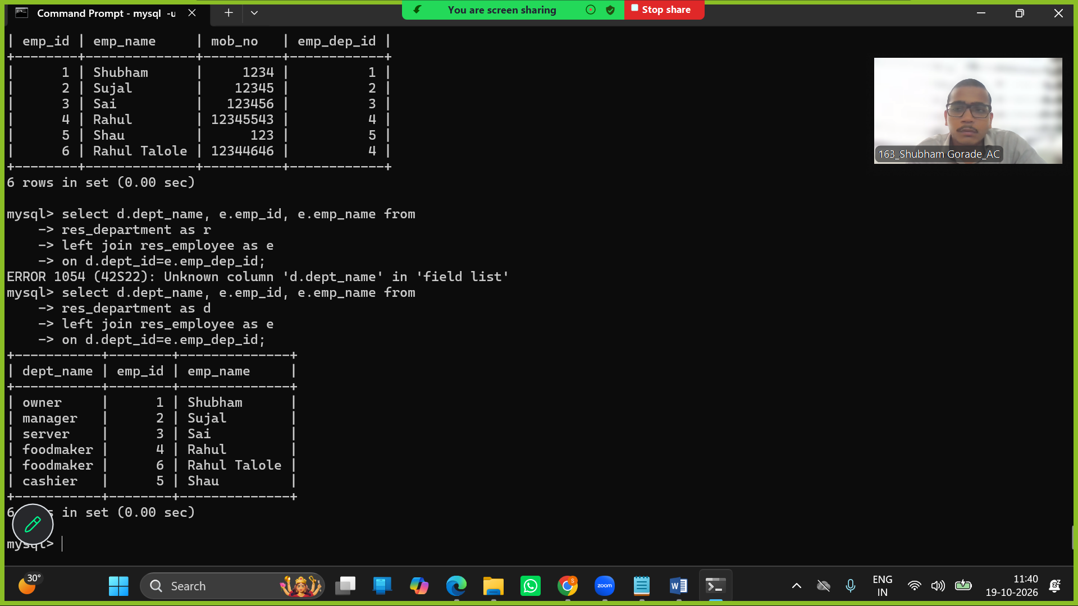

Q11
create temporary table menu_chinese (Chinese varchar(30));

insert into menu_chinese values ('chiken lollipop'), ('noodles');

drop table menu_chienese;

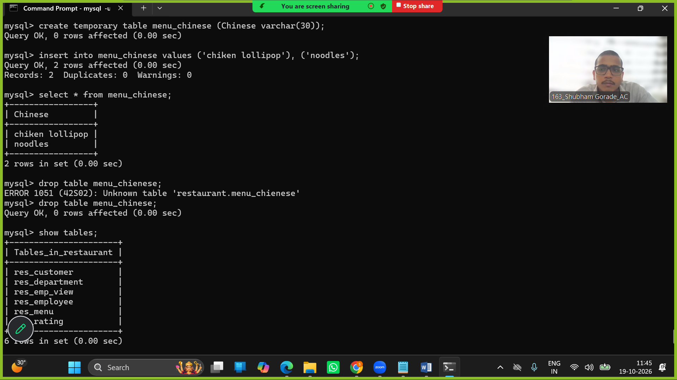

Q12

Q13
delimiter //
create procedure even_no
begin
declare i int default 1;
loop_even : loop
if mod(i,2)=0
then select i as evenno;
end if;
set i=i+1;
leave i=11;
end loop loop_even;
end //
delimiter ;

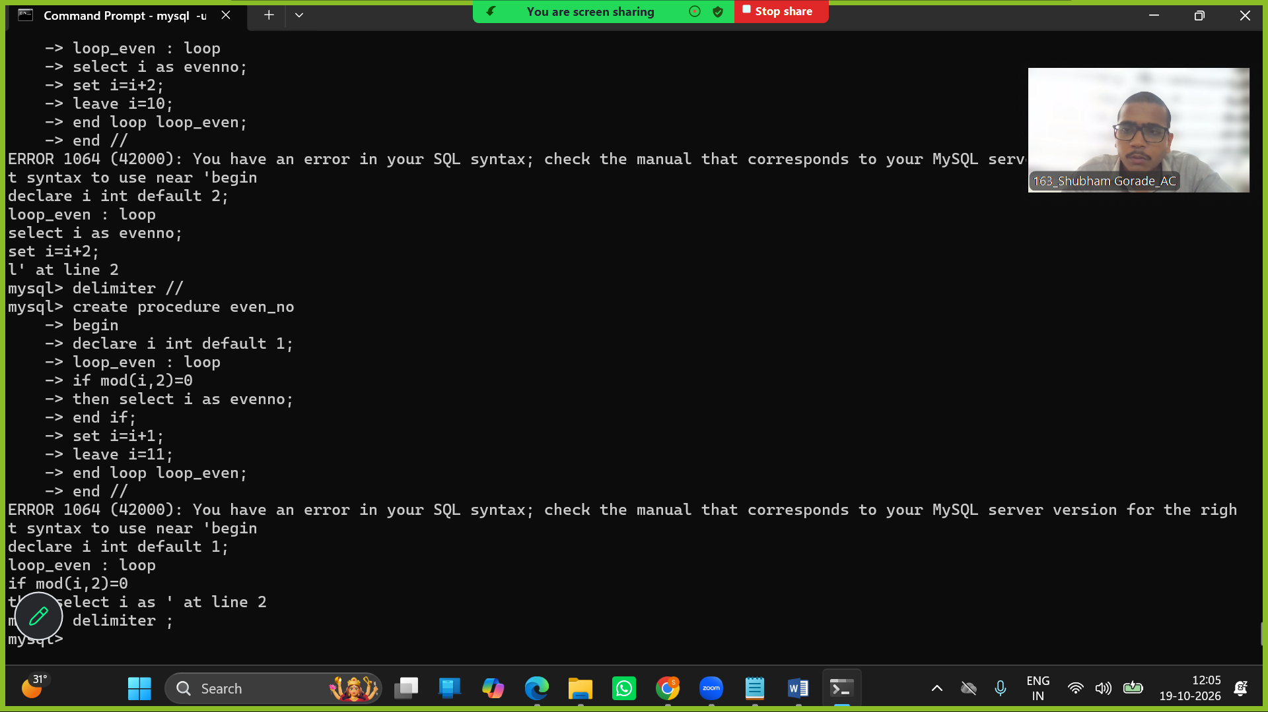

Q14

